Social media toolkit: Time to take action
January 23, 2017

Overview:

Many issues were brought to the forefront during the weekend’s events across the country. Ultimately, we want to continue the momentum of people standing up and taking action for the causes they care about. Whether it’s climate change and rising tides, the environment, the ocean, or the planet, we want to encourage people to get involved and be part of the solution – to attend a chapter meeting or upcoming event, join as a member, renew or give a donation to support the work to protect our ocean, waves and beaches for the future. Please note, as a 501c3 organization, we need to focus specifically on the issues that are relevant to our mission and avoid focusing on specific politicians or people. Our goal is to rally more people to take action on a local and individual level and help create lasting change by making a difference in their communities, regions and together, through a powerful activist network.

Below is sample messaging for chapter and regional social media channels and further below are legal guidelines from Angela to use as a resource for messaging (please be sure to read through prior to posting). Thank you for helping to rally others to get involved and transform passion into action for the protection of our ocean, waves, beaches and planet. Long Live The Beach!

Facebook:

Time to take action and stand up for the causes you care about. Join us and #makeadifference for the protection of our ocean, coasts and planet through a powerful activist network. Get involved and attend a #Surfrider chapter meeting, become a member, renew or give a donation to support our network of volunteer coastal defenders who stand up day in and day out to protect our ocean, waves & beaches for the future. Join us at: Surfrider.org/support-surfrider.

With more than 400 coastal victories, the #Surfrider network has demonstrated that if we organize and work together, we can advance coastal protection, even in the face of major challenges. Now, more than ever, we need to join together, rally more people to our cause and build and even stronger movement to protect our ocean, waves and beaches for today, tomorrow and every day after. Join us at Surfrider.org/support-surfrider. Long Live The Beach!

Our ocean and coasts face growing challenges from pollution, offshore development and oil drilling, climate change and #risingtides. Join us and be part of the solution as we work together to protect the world's ocean, waves and beaches through a powerful activist network and advance coastal protection. Join us at: surfrider.org/support-surfrider!

Instagram:

We rally. We protect. And together, we win. Get involved and join us as we work to protect our ocean, waves, beaches and planet for the future. Join us via link in profile! (link in profile: Surfrider.org/support-surfrider).

Time to stand up, take action and #protectwhatyoulove. Join Surfrider’s growing network and become a member, renew your #membership or give a donation to support our volunteers who work to protect #cleanwater, #beachaccess, #coastalpreservation, #oceanprotection and prevent plastic and pollution from impacting our ocean & coasts. Join us and #makeadifference via link in profile. (link in profile: Surfrider.org/support-surfrider)

Want to make a lasting difference for the protection of our ocean, coasts and planet? The work of grassroots organizations is more critical than ever. Surfrider’s local activism and stewardship allow our network to pass proactive policies at the state and local levels, while our network’s vast coverage across the U.S. provides defense against threats such as offshore development and oil drilling, rising tides, and pollution. Join us and create lasting change – attend a Surfrider chapter meeting, upcoming event, or join, renew or support the protection of our ocean, waves and beaches for the future. Check link in profile to get involved! (link in profile: Surfrider.og/support-surfrider).

Twitter:
We rally. We protect. And together, we win. Join us and #protectwhatyoulove at Surfrider.org/support-surfrider.

Time to activate for the causes you care about. Make a lasting difference & #protectwhatyoulove at Surfrider.org/support-surfrider.

Be part of the solution. Join us and help protect our ocean, waves, beaches & planet for the future at: Surfrider.org/support-surfrider.

Weblinks:
Surfrider.org/support-surfrider
(Or your chapter’s website link)

Hashtags:
#Surfrider
#SurfriderFoundation
#protectwhatyoulove
#protectandenjoy
#protectwhereyouplay
#takeaction
#LongLiveTheBeach
#forthefuture
#healthyocean
#healthycoasts
#healthyplanet
#climatechange
#risingtides
#makeadifference
#cleanwater
#beachaccess
#coastalpreservation
#oceanprotection
#plasticfree

Primary photo assets:

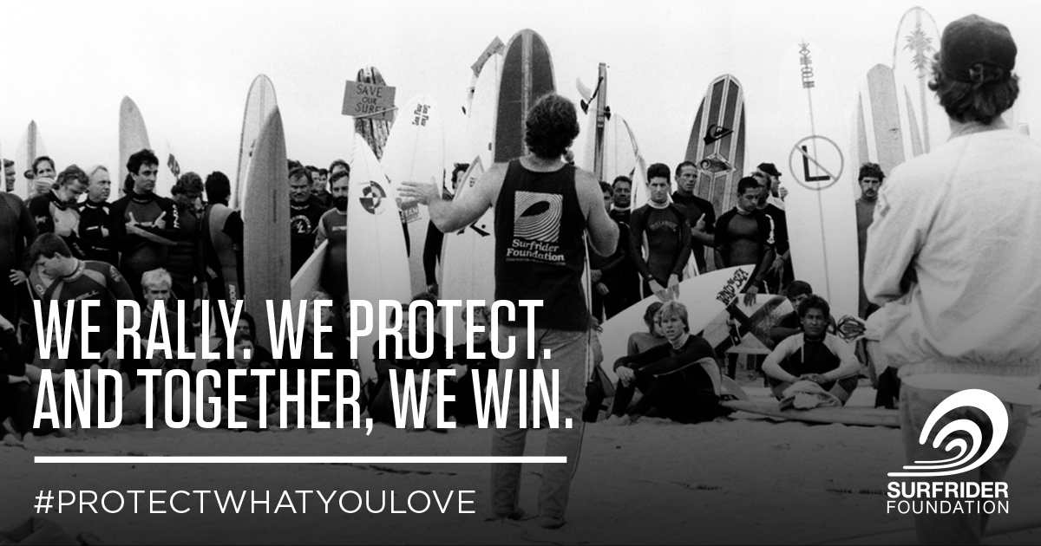

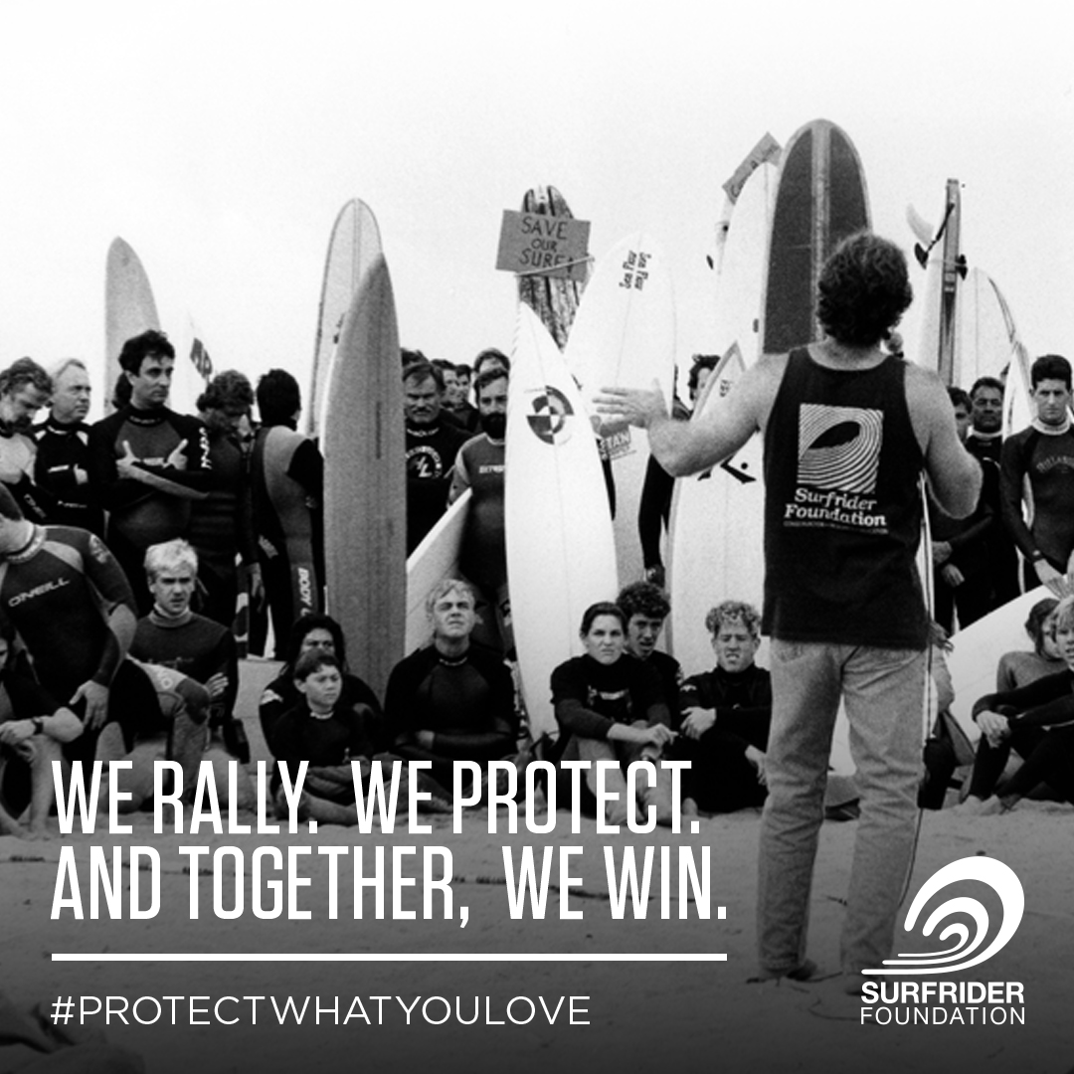

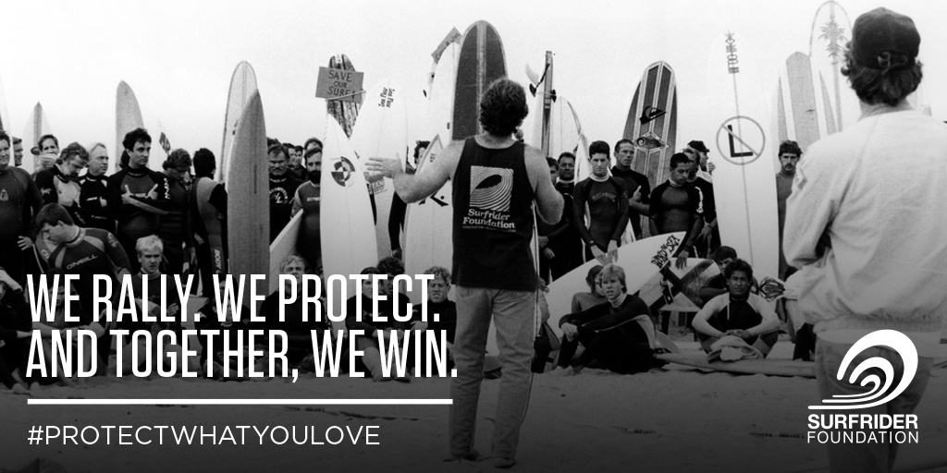

Message guidelines from Angela Howe, Sufrider Legal Director:
As you know, as a 501c3, we have to be very careful regarding the manner in which we engage on any election-related issues, including the post-election marches. We have discussed this at the Directors level and with communications staff and we recommend that we do not promote the protest marches on Surfrider channels. Of course, you are perfectly free to do so in your individual social media and other communications. However, we need to keep our messaging consistent with our nonpartisan mandate.

Here are a few guiding points and background from a recent memo to our Board of Directors on this topic below.

Sincerely,
Angela

Here are examples of advice regarding the non-partisan mandate that has been shared with staff:

- Since we are a 501c3 and not a c4, we have to be careful about how we talk about President-Elect Donald Trump. We need to do a good job of listing facts in order to be on the “issue-specific” instead of “candidate-specific” side of the line. We want to be careful to not comment in any way that could be considered disparagement or partisan in any way.
- In order to be clear that this communication is about the issue and not the person, it is best to use “Trump Administration” versus simply “Trump” to discuss a recent government administration decision.
- We must keep our messaging positive and in a non-partisan light, we must describe our campaigns as a battle/concern for the environment (not a fight against Trump).
- According to Adler & Colvin, a law firm that counsels non-profits, it is safe for a charity to focus on policy issues that you’d like to see the winning candidate address. Charities should also avoid indicating that they intend to hold the elected candidate accountable in a way that is susceptible to being interpreted as a reference to a future election.

Background Information

As a general matter, the Surfrider Foundation (the “Foundation”), a tax-exempt 501(c)(3) organization, may not participate in political campaigns for elected office. Violations of this restriction can lead to heavy penalties, such as the revocation of the Foundation’s tax-exempt status. The Internal Revenue Service (“IRS”) does, however, allow tax exempt organizations to participate in the political process, provided that they do so in a nonpartisan way.

Surfrider Foundation’s non-partisan 501(c)3 mandate is a prominent part of the organization’s governance structure and featured in the Organizational Bylaws and Chapter Bylaws.
The Foundation’s Organizational Bylaws read in Article III, Nonpartisan Activities:
This Corporation, formed under the Nonprofit Public Benefit Corporation Law for the purposes described above in Article I, shall be nonprofit and nonpartisan. No substantial part of the activities of the Corporation shall consist in attempting to influence legislation, and the Corporation shall not participate or intervene in any political campaign on behalf of any candidate for public office.
The Corporation shall not, except in an insubstantial degree, engage in any activities or exercise any powers that are not in furtherance of the purposes described above.

From Chapter Bylaws, Article I, section 2(e):
The Surfrider Foundation strives to be accurate and nonpartisan in its communications with its members and the public at large and strives to express the unique values inherent in wave riding: individualism, camaraderie, non materialism and an appreciation for historic relations with the ocean.

The Chapter Bylaws go on to state in Article I, Section 3 that no chapter shall partipate or intervene in a political campaign on behalf of or opposition to any candidate for public office.
Additionally, the Legal Department routinely gives guidance to chapters regarding participation in activities that may run afoul of the 501(c)3 guidelines and have official guidelines, memoranda and IRS guiding documents available for chapters.

