SAMPLE MEDIA ALERT/ TEMPLATE
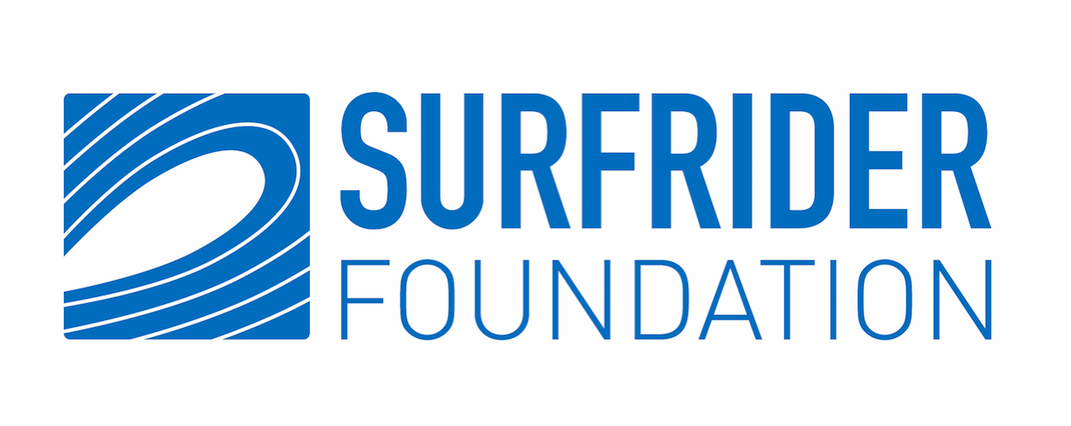
MEDIA ALERT: COMMUNITIES JOIN HANDS IN OPPOSITION TO OFFSHORE OIL DRILLING
(Location xx) Saturday, May 18th, 2019
[BACKGROUND]:
On May 18th at [local time], coastal communities across the U.S. will join hands for 15 minutes at beaches and parks to demonstrate support for protecting our coasts from dangerous and destructive offshore oil drilling. Founded by Surfrider member Dave Rauschkolb in 2009, Hands Across the Sand brings communities together to take action and stand up against unnecessary new offshore oil drilling and seismic air gun blasting off our nation’s coasts.

Last year, the Trump administration announced a proposal to expand offshore oil drilling in U.S. waters, threatening ocean recreation, tourism and fishing industries, which provide more than $115 billion in GDP and over 2.2 million jobs nationwide. The Draft Proposed Five-Year OCS Offshore Oil and Gas Leasing Program released by the Interior Department currently includes planned drilling in the Atlantic, Pacific, Gulf of Mexico, and Arctic Ocean. This extreme proposal opens up more than 90% of our nation’s coasts to new oil drilling and puts our communities, beaches, surf breaks, and marine ecosystems at risk of a catastrophic oil spill.

The Surfrider Foundation is an official sponsor of Hands Across the Sand. For more information, visit the event website or Surfrider.org.

Who: Surfrider Foundation [your Chapter]

What: Hands Across the Sand, taking place across the U.S.

When: Saturday, May 18, at [local time]

Where: [Locations]

Contact: [On-site contact email/ phone number information]

###
About Surfrider Foundation

The Surfrider Foundation is a non-profit grassroots organization dedicated to the protection and enjoyment of our world’s oceans, waves and beaches through a powerful activist network. Founded in 1984 by a handful of visionary surfers in Malibu, California, the Surfrider Foundation now maintains over 500,000 supporters, activists and members, with more than 80 volunteer-led chapters and 70 clubs in the U.S., and more than 450 victories protecting our coasts. Learn more at surfrider.org.

